

DEPARTMENT OF COMPUTER SCIENCE AND ENGINEERING

ISLAMIC UNIVERSITY ,KUSTIA

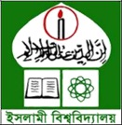

COURSE NAME : COMMUNICATIVE ENGLISH

COURSE TITLE : 1105

COURSE TEACHER : MD.ALAMGIR HOSSIAN, SIR

COURSE TYPE : IETLS COURSE

MD.MAHFUJUR RAHMAN

ROLL NO: 1419037

SESSION: 2019-2020